|  |  |  |
| --- | --- | --- |
| Student Number | Student Name | N |
| 442850342 | ريم خريزان الصخابرة | 1 |
| 443850383 | وصال سالم الدماعين | 2 |
| 442850306 | شذا إبراهيم ال زعير | 3 |
| 442850288 | رفعة راشد الصخابرة | 4 |



Kingdom of Saudi Arabia

Ministry of Education

Prince Sattam Bin Abdul-Aziz University

College of Computer Engineering and Sciences

Project

Threads

المملكة العربية السعودية

وزارة التعليم

جامعة الأمير سطام بن عبد العزيز

كلية هندسة وعلوم الحاسب

ريم الصخابرة

: Feasibility Study &Project Proposal : 1

**Introduction:**

Threads is a Social media application, owned by the American technology company Meta Platforms. The application works similarly to Twitter or (X), where users can post texts, photos, and videos; In addition to responding to others’ posts and liking them.

**Problems:**

posts are now automatically translated based on the language they’re written in and the language setting of the person viewing it.

It allows for more privacy, such as not being able to see the last time you used the application.

**Background**:

Meta Platforms is a technology conglomerate that owns and develops some of the most popular social media platforms including Facebook, Instagram, WhatsApp and others . The current CEO of Meta is Mark Zuckerberg Founded on July 4, 2004 and based in Menlo Park, California.

**Proposed solution:**

The problem of few characters: The program allows users to use 500 characters.

The problem of the duration of the short clip: The program allows publishing videos that are up to 5 minutes long.

Story problem:The program allows you to specify the people you want to see your story.

**Work Plan:**

Waterfall Model : A plan-driven approach to software engineering is based around separate development stages with the outputs to be produced at each of these stages planned in advance

-Requirement Gathering and analysis

- System Design

- Implementation

- Integration and Testing

- Deployment of system

- Maintenance

‎



Project requirements : : 2

ريم الصخابرة

**Write the FR perfectly(8)?**

Statements of services the system should provide, how the system should react to particular inputs and how the system should behave in particular situations

We have two actors , they are :

- Admin - Users

The Administrator should be able to:

- Login.

-Modify personal information.

- Delete user account.

- Add ,view , modify or delete section.

- System Security.

- Access to databases.

- data accessibility.

- Logout.

The users should be able to:

- Login.

- Modify personal information.

- Add or delete comments.

- Access account status.

- Contact the support team.

- suggested content.

- Privacy settings.

- Logout.

**Write the NFR perfectly(4) ?**

Constraints on the services or functions offered by the system such as timing constraints, constraints on the development process, standards, etc.

Usability: The clarity of the website so that users can use it easily.

Security: Protect the site from hack so every user should have a

account with a minimum password with 6 characters.

Accessibility: The system shall be accessible by several users at the same time.

Portability: The possibility of running the site on all Internet browsers.

3 : Activity diagram:

رفعة الصخابرة

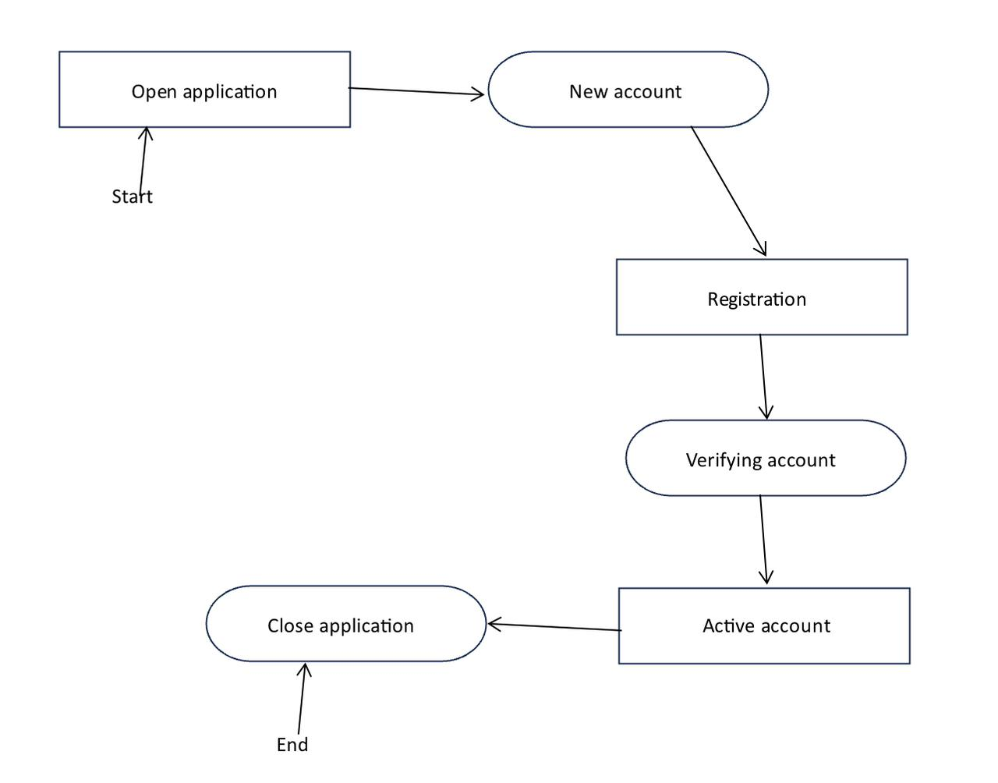

4: Project Use Case Modelling :

وصال سالم

**Actors Table:**

|  |  |
| --- | --- |
| Actors | Roles |
| Users | - Create a new account.  - Login with their username and password.  - Follow new accounts.  - Create a new post.  - Respond on other users’ posts.  - Search for other users. |
| Creators | - Share Ideas and Threads.  - Connect with followers.  - Engage in conversations.  - Respond on followers’ comments. |
| Threads Team | - Maintain and develop the Threads application.  - Expand Threads’ features.  - Ensure safety and users control.  - Respond to users inquiries. |

**1. Users**

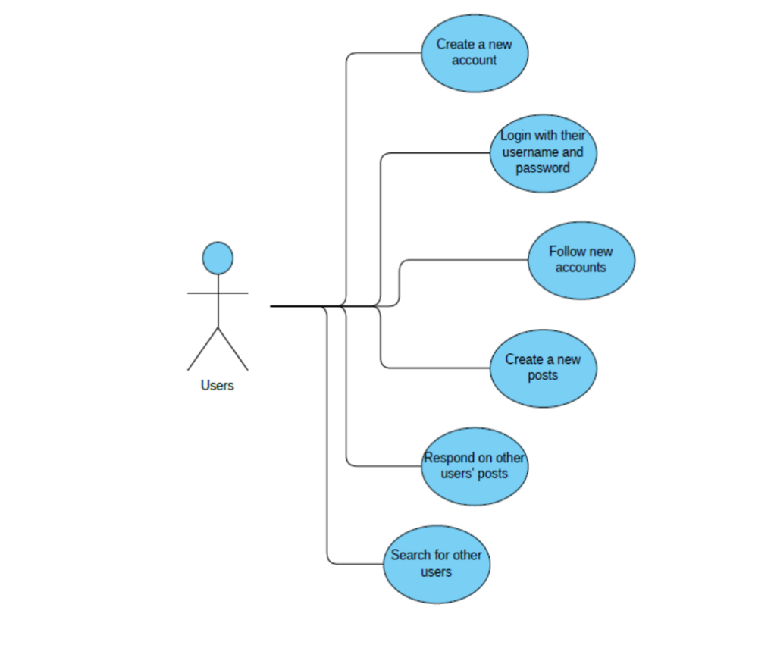

**2. Creators**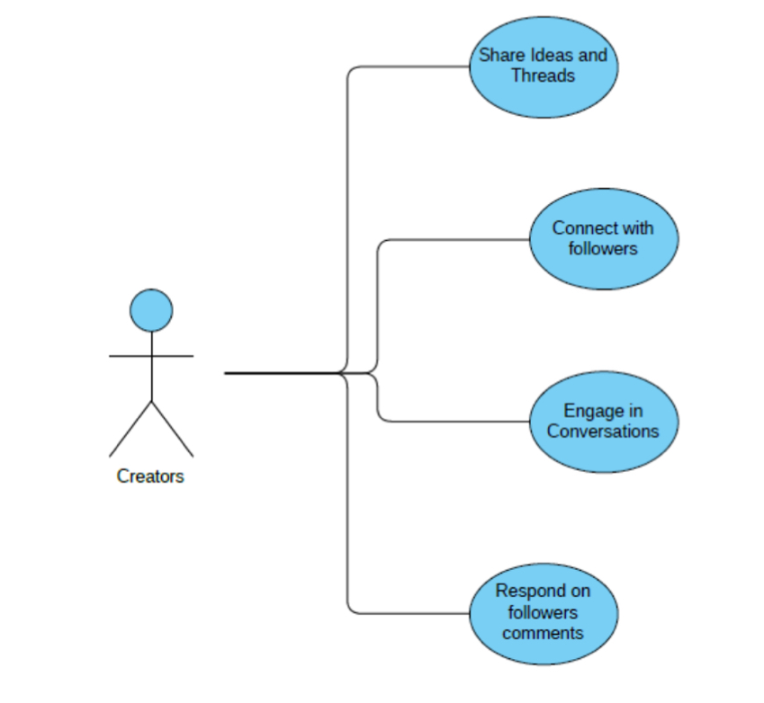

**3. Threads Team**

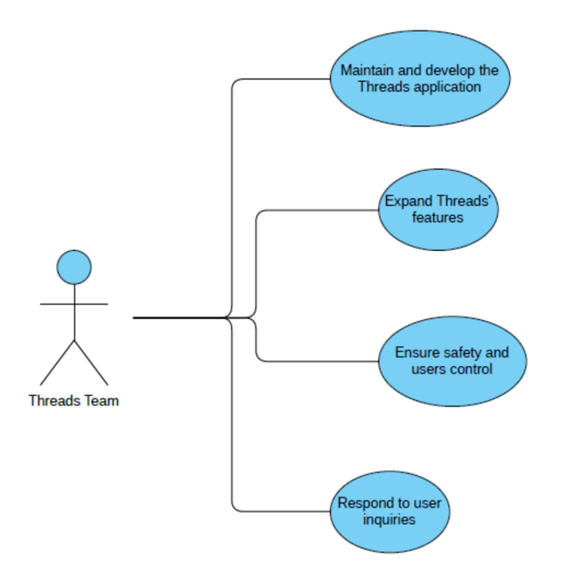

|  |  |
| --- | --- |
| **Users: Create new post** | |
| Actors | Users and database of posts |
| Description | Users can create new posts on the "Threads" web application. These posts are stored in a database of posts. |
| Data | User-generated content, including text, images, videos, and captions, voice, poll ,and Control who can comment on post . |
| Stimulus | User action to create a new post by composing and submitting content through the "Threads" interface. |
| Response | The new post is saved in the database of posts and becomes visible to other users on "Threads". |
| Comments | Users should be registers before they can creating any posts. |

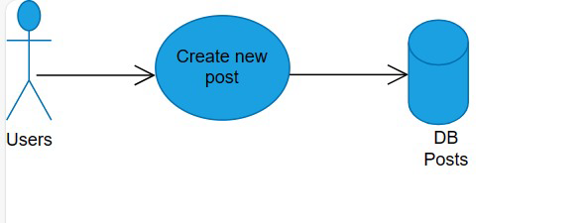

|  |  |
| --- | --- |
| **Users: Search for other users** | |
| Actors | Users and database of all user accounts |
| Description | This use case involves users searching for other users within a system or platform. |
| Data | The system or platform should have a database of all user accounts, which includes information such as usernames, profiles, and other relevant details. |
| Stimulus | A user initiates a search for other users by entering specific criteria or keywords such as, username. |
| Response | The system retrieves and displays a list of users that match the search criteria, including their usernames, profiles, or other relevant information. |

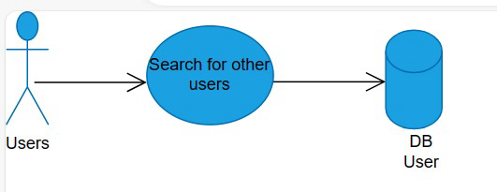

شذا ابراهيم

5 : Creating Sequence Diagram:

**Check System**

**Home page**

**DB : post**

**User**

**Post Texts # photos and Videos# Poll# Voice# Control who can comment on post#**

**Post Page [Ok]**

**Check Information[file]**

6: Creating a Class Diagram :

رفعة الصخابرة

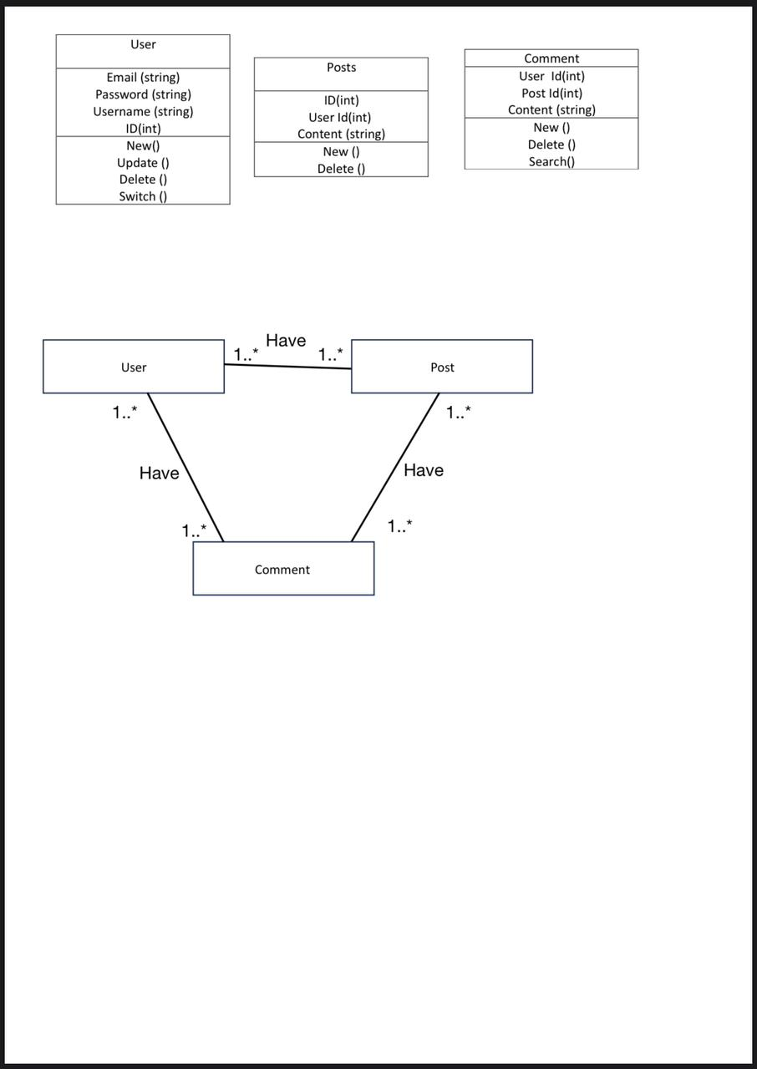

7: Presentation Slides:

THE END

تم كتابة التقرير بواسطة : شذا إبراهيم و ريم الصخابرة

وصال سالم